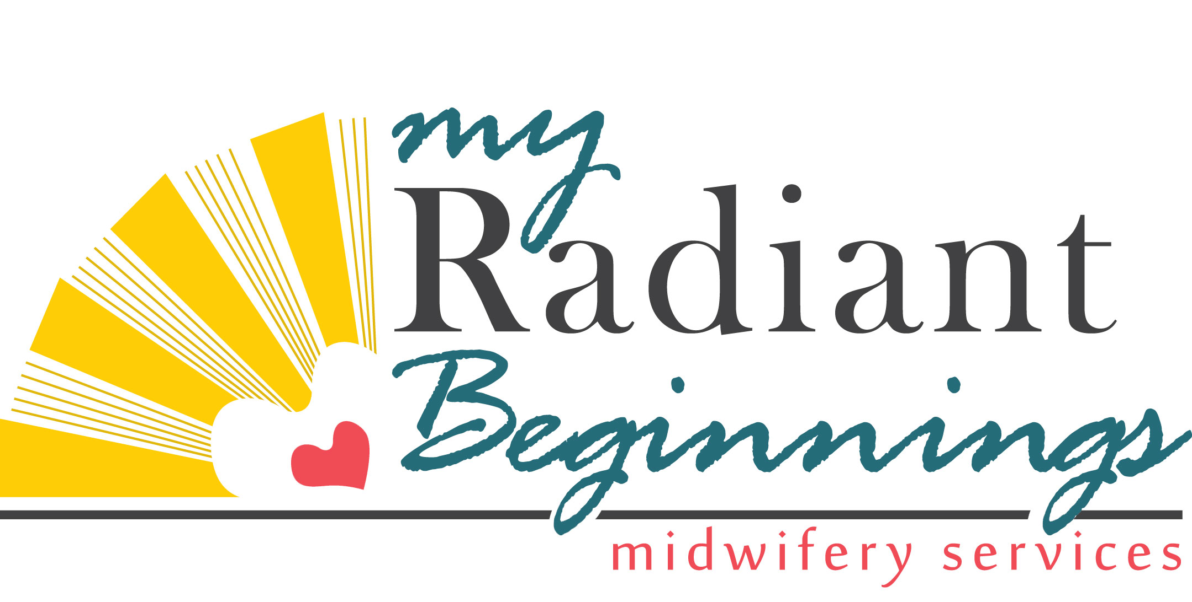

Documentation of Information Texas Law Requires Pregnant Women Receive
http://www.myradiantbeginnings.com/resources.html

In compliance with Texas Health and Safety Code, Chapter 81, Section 81.090, “Serologic Testing During Pregnancy,” effective January 1, 2010 I have received from my midwife a copy of:

______ If You are Pregnant or Think You May be Pregnant, You Need to Know about HIV
______ Pregnant? Protect Your Baby from Syphilis
______ If You are Pregnant or Think You May be Pregnant, You Need to Know about Vaccine-Preventable Diseases (Hep B & Rubella)

In compliance with Texas law (HB 3336), effective June 17, 2011, I have received from my midwife a copy of:

______ Information for Parents of Newborn Children
______ The Guide: A listing of non-profit mental health services for Harris County

In compliance with Texas law (HB 709), effective 2007, I have received from my midwife a copy of:

______ Information on Umbilical Cord Blood Banking and Donation

In compliance with Texas law (HB 1240), effective September 1, 2009, I have received from my midwife a copy of:

______ A Parent’s Guide to Raising Healthy, Happy Children

All of the above resources are linked on my website at the url listed above. Please take your time to read through the information. Your signature indicates I have made you aware of this information and provided you with access to it.

________________________________________________________________
Client’s Name (Printed & Signed) Date

